**Dental Care Supply**

**Louisiana (LA) Notes**

**by Chris Larkins**

* I used the LA file from the dropbox for the BOD dentists. The file was collected on 2.5.20. Because the file required payment, the file from 2.5.20 was used rather than a more updated file.
* The “IKN_processed.csv” file and “[NP_national_w_extra_col_2n.csv](http://localhost:8888/view/Dental%20Care%20Supply/NP_national_w_extra_col_2n%20(1).csv)” files were used
* Anything that mentioned “hygienist” was disregarded according to recept dropbox updates.
* I used the PA/IL code/process on dropbox to help formulate my code for LA.
* The MED + CHIP + BOD FTE sum of dentists is 2,925 (2,255 unique). The 2018 ADA total is 2,228.
* This original BOD file from 2.5.20 includes:
  + 2,615 rows of Dentists, without any hygienists.
  + Dentists designated as “ACT” or “PRB.”
    - 2,613 Active
    - 2 Probation. The licenses on probation were dropped in the BOD pre-processing stage.
    - 86 (3%) of rows had an expired license. All but one of the expired licenses expired on 12.31.19. Expires licenses were dropped in the BOD pre-processing stage.
    - Robert Edward Bruns IV was the only row with a state of “Louisiana.” This was changed in the original file to “LA” like the rest of the LA rows.
  + 2335 (89%) rows have a LA BOD address.
  + The Columns Headers Include:
    - *LICENSEID Type FIRSTName MIDDLE LASTName Address1 Address2 CITY STATE ZIP STATUS DateSince Class DateUntil SPECIALTY*
  + Approximately 10 rows were edited immediately before any analysis where the address line 1 included the name of the location or office and the address line 2 included the actual address. Therefore, for these 10 rows, the addresses were fixed so that the address line 1 included a mailing address. This did not fix all address issues.
  + One person was listed as “retired” in the address column. They were removed at the end of the BOD pre-processing stage.
* **The original IKN-NPPES match rate using names was around 55%.** This led me to discover that for almost all IKN, LA rows with a *LIC_NUM* = 0 and *PROV_AFF* = 0 , a dentist credential (i.e. DDS, MD, DMD, etc.) was included after the *PROVIDER_LAST_NM*. For example, Jorge Anguilar has a row with his name as “Jose Anguilar” and “Jose Anguilar DDS.” Since the IKN Technical Guidelines listed both columns as “optional,” I concluded that these rows should be kept for matching. Therefore, using pandas, the dentist credentials were taken out of the *IKN_names* and *Provider_Full_NM2* columns. In total, DDS was removed from 729 rows, DMD from 7 rows, MD from 2 rows, DS from 6 rows, DD from 1 row, and “DD S” from 3 rows (See below for the code). **After the change, the IKN-NPPES match rate using names was 78.9%. The final IKN-NPPES match rate was 89.0%.**
* 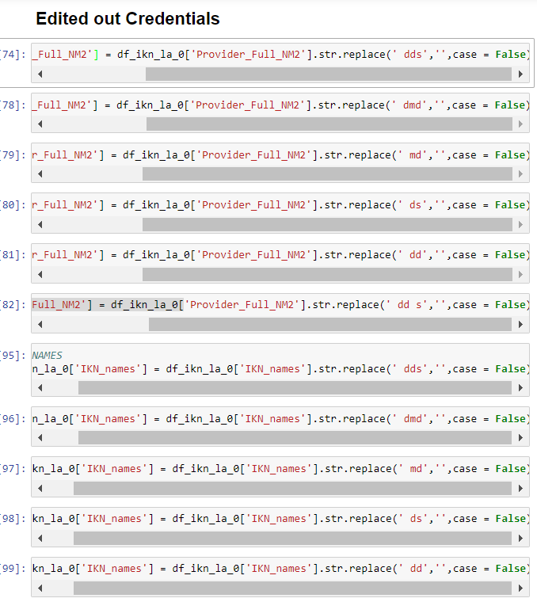
* At least 758 of the 5642 (11.8%) rows in the original IKN-LA csv did not have a real NPI. The NPI digits were <10. This led to a poor, 68.6% IKN-NPPES match using NPI’s.
* The overall IKN match rate was 78.3%
* After Exclusions, there were 2788 MEDICAID values, and 453 BOTH values. No CHIP values. The BOTH values were then included into both Medicaid and CHIP files.
* Interestingly, my final specialty sum files for BOD and CHIP had no decimals for general, specialist, and pediatric. It looks like all but 10 or so dentist locations offering CHIP have multi-purpose offices. They are either general, specialist, or pediatric. Very little overlap, unlike Medicaid.
* There was a large discrepancy in filtering out names between Provider_Full_NM2 and BOD_Formatted_Name. BOD_Formatted_Name was used because the final head count of dentists was much closer to the 2018 ADA value.